Wendover Arm Trust 25th September 2020
Operations Report
Website: - http://wendoverarmtrust.co.uk/
Overview
A very productive two-week work party! The weather was on our side again and helped with our focus on block and brick work at Bridge 4 and at Whitehouses.

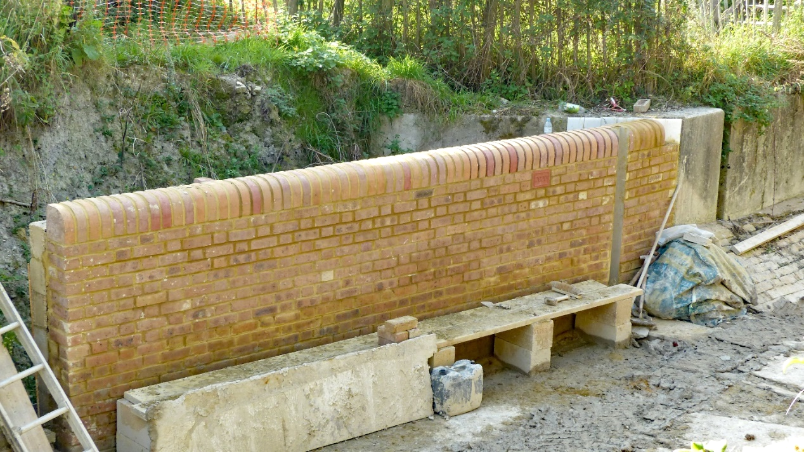
The offside wall almost completed. Note the stop plank channel built in at the right-hand end.
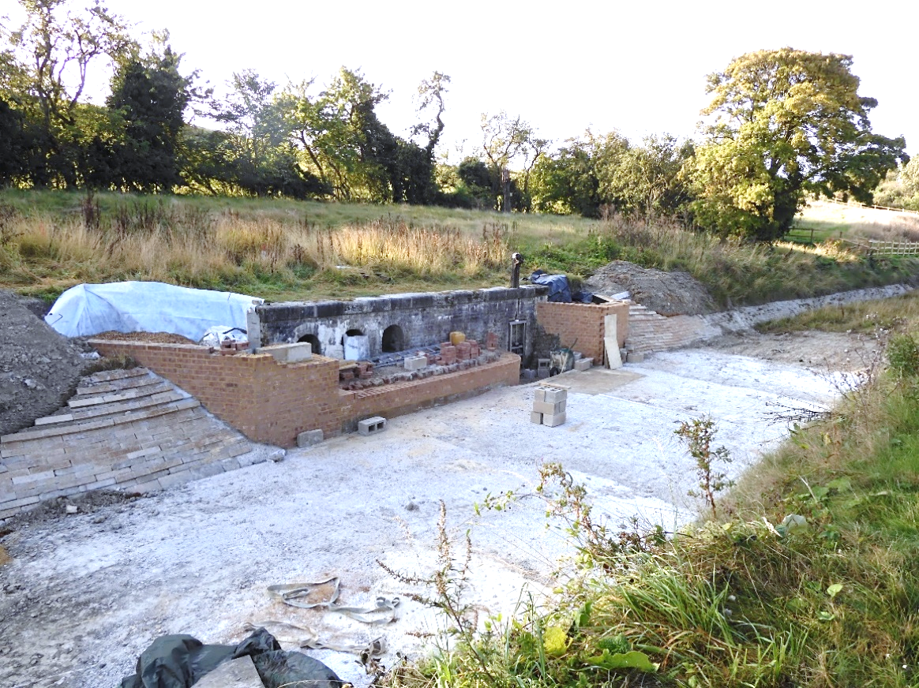
Whitehouses showing the block work completed and the wing walls nearly finished (finished a few days later). The top of the front apron requires one more row of bricks. The banks either side are finished. The 300mm thick reinforced concrete slab in front of the structure has been completed.
A close-up view of the Right-hand wing wall before the bank was back filled with soil

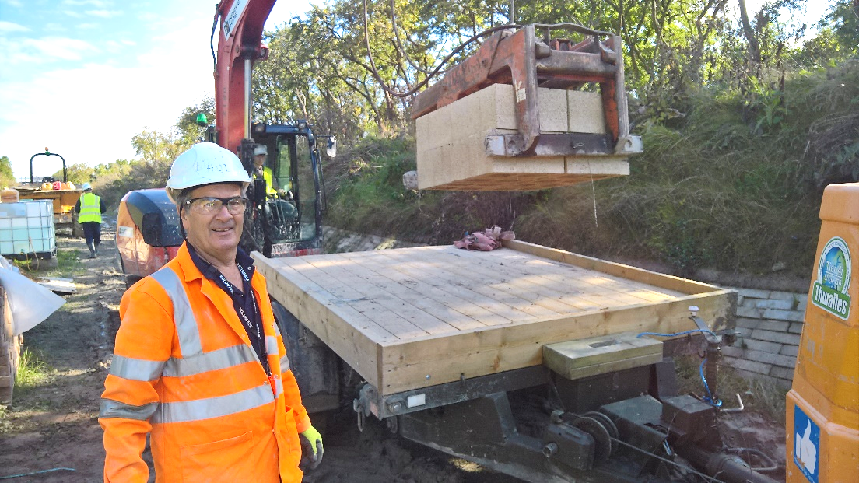
This volunteer is smiling because the concrete blocks are being unloaded with a hydraulic grab from the trailer. He won’t have to lift them one by one, by hand!

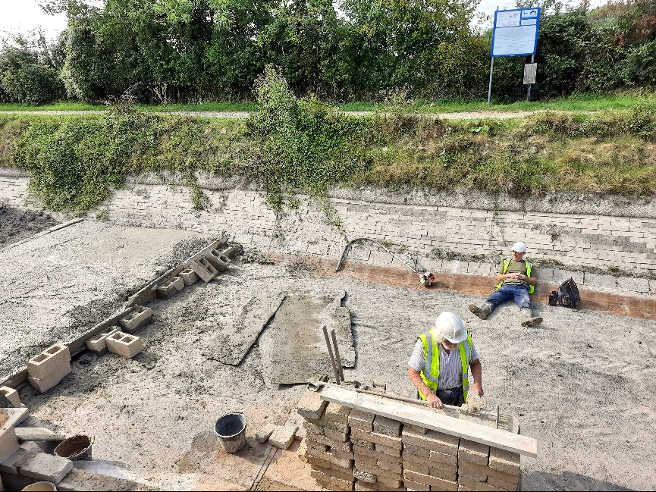
Time for a rest, after three socially distanced volunteers have wrestled 4 cubic m of reinforced concrete into place! One of the warmest Septembers on record…..
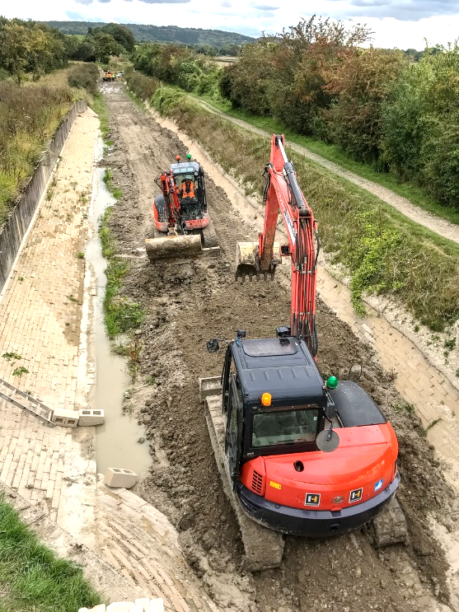
The bed from Bridge 4 back to Whitehouses (Just visible in the distance) was built up to allow excavators and dumpers to deliver materials. Note the water level along the mooring wall blockwork. The extra spoil will have to be removed before flooding this section.
At the end of the two weeks all the remaining heavy materials and tools were moved back to bridge 4 in case wet weather makes it impossible to get excavator and dumpers back to the site in October.
Subgroups
Two new working teams/subgroups have been set up, both reporting to the Operations Director. One of these is the Environmental group and the other is the Domestic Tip excavation group.
Environmental Group Remit
Advise and actively manage activities that drive a positive net environmental gain during the restoration of the canal.
Provide informed opinion on environmental legislation and issues relating to the restoration.
- Develop and actively manage an action plan for the protection of wildlife, working closely with the Operations team, during the restoration.
- Promote the environmental benefits of the canal restoration to the public, our sponsors, and stakeholders.
Domestic Tip Excavation
As many of you know, there is a historic Council domestic waste tip in the bed of the canal at Little Tring. This has been a headache for the Wendover Arm Trust for many years, but we have a made a breakthrough in being able to clear this area. A new team has been formed to handle the clearing of the domestic tip.
As part of the tip area clearance we are having to deal with an active Badger sett. We have found a reputable company to advise and handle the licensing aspects of dealing with this protected species.
Further information on the Tip clearance will appear in next month’s Operations report.
Tony Bardwell
Operations Director

