Wendover Arm Trust 25th October 2020
Operations Report October 2020
Website: - http://wendoverarmtrust.co.uk/
Overview
The Covid 19 arrangements have worked well this month with separated work areas and a vigilant Volunteer team.
We had the wettest October Tuesday (3^{rd)} since 1891 and this affected some of the work that was programmed. The effect of the rain was to create a large amount of mud and slurry. Although this did not stop the machines from getting through it did make working at Bridge 4 difficult and more hazardous for some operations such as concreting
Whitehouses
The wing walls and concrete coping blocks have been completed. The sluice “benching” has been completed. The paving on top of the wing walls and some pointing of the old brick work remains to be done
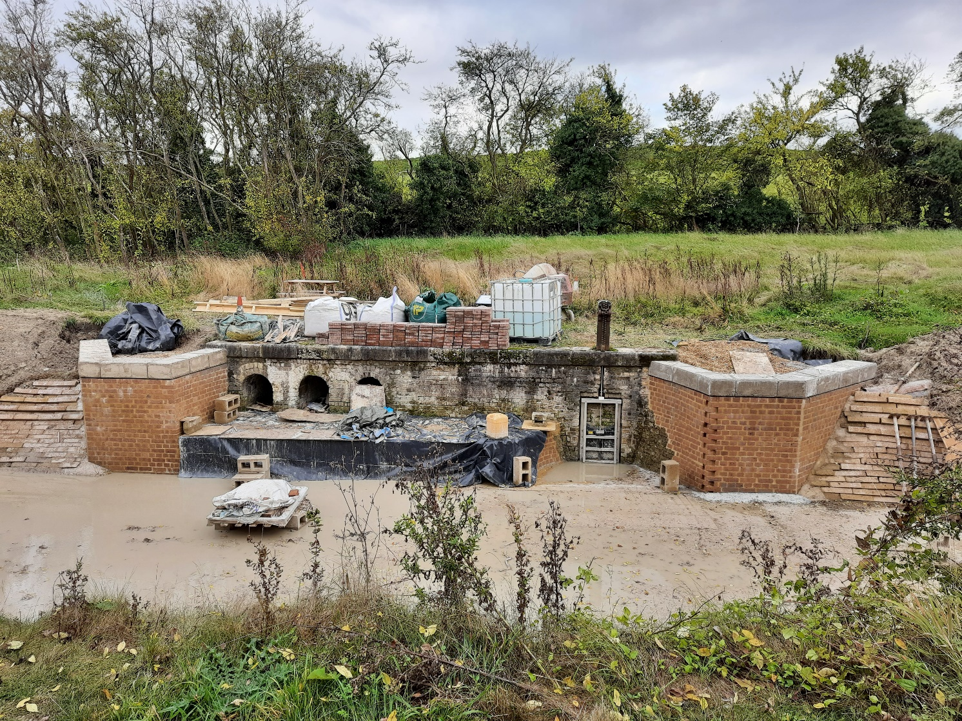

Bridge 4 walls
The new walls containing the stop plank channels have been very nearly completed with a row of “soldier” bricks on the top face remaining to be done. We have measured the stop plank channel positions and designed the stop planks to fit. We are currently raising a purchase order for the planks
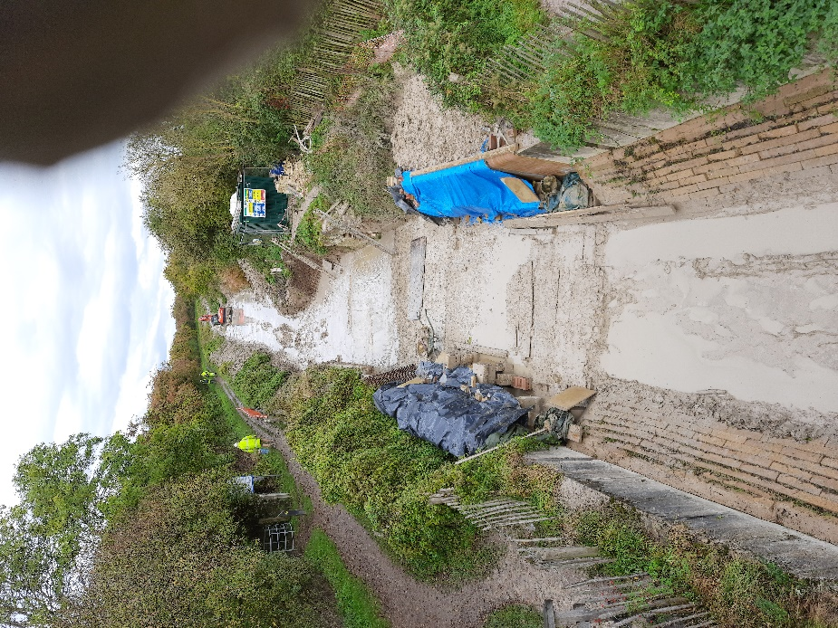
The view from bridge 4 showing a large lake of water and mud in the distance. Under the blue covers are the two new walls protected from the weather
One of the main tasks over this work party, was to cast 16 cubic metres of reinforced concrete between the Old Swing bridge walls to stabilise the foundations. This was done over several days and was hampered by the quantitiy of mud and water that proved to be difficult to control. As can be seen in the picture below we did create a clean/dry area for the concrete but the dumpers “cut through” the temporary bunds and water/mud/poured through. Unfortunately when you have a concrete delivery you can’t stop half way through and send the remainder back!
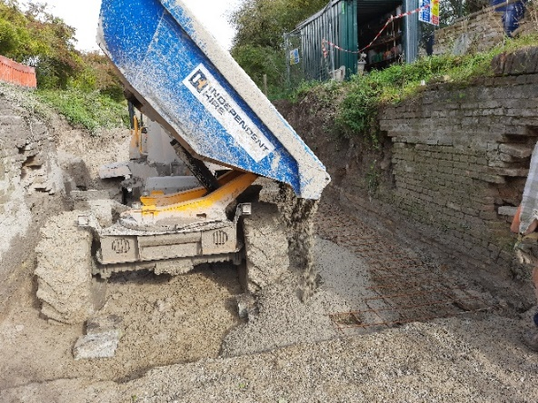
The first concrete pour on a clean and dry area, little did we know what would happen next!
Whilst excvating for the concrete work a new length of wall was discovered on each side of the canal. These are continuations of the previously exposed walls. As can be seen in the picture these walls curve back into the banks. On the offside they curve back under our No.1 hut and portaloo so those will need to be moved soon. These walls also contain the remains of another set of stop plank channels.
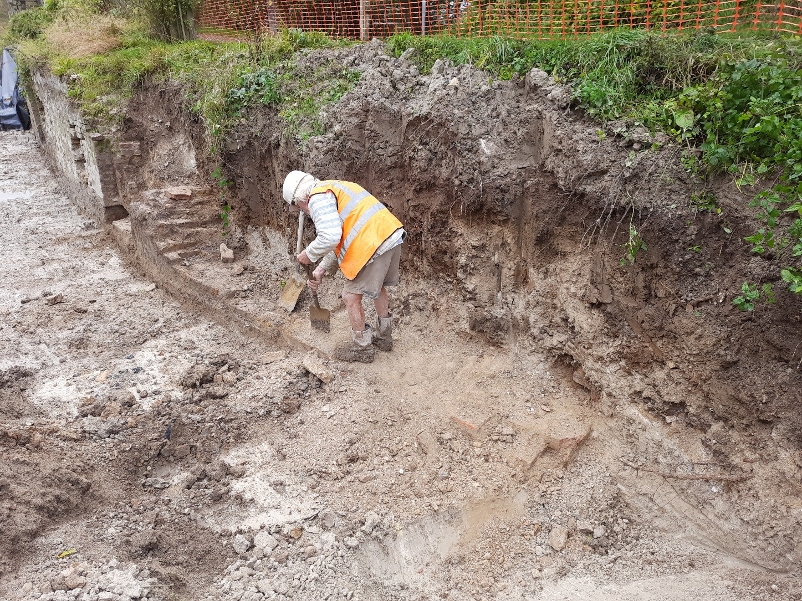
We expect to be rebuilding these walls back to the same height as the previously exposed walls.
Historical refuse Tip Excavation
Together with a Sub Contractor we have developed a process and method to potentially remove the tip material placed in the canal length close to the winding hole at Little Tring. A test/trial excavation and removal of part of the tip is being planned.
New volunteers and Public comments
During this work party we have attracted yet more volunteers, this was mainly a result of asking for skilled brick workers to work on Whitehouses and Bridge 4 walls. During the brick laying activity on site we had many positive comments from members of the public who were walking past. The fact that we are rebuilding the walls and structures seems to impress everybody who sees it!
Tony Bardwell
Operations Director

