Wendover Arm Trust 15th August 2020
Operations report July 2020
Website: - http://wendoverarmtrust.co.uk/
Introduction
This is a brief report of the work carried out during the first work party for several months due to Covid 19 lock downs and restrictions.
Overview
A return to site started on 16th July with plant machines being delivered. Volunteers arrived on site the next day. The Covid 19 (C19) arrangements arising from our risk assessment have worked well enough to go beyond the trial period. However, there were some more tasks that need to be taken on to improve our arrangements for the August work party starting on 6/7th Aug.
Work tasks
The first part of the week was spent moving materials down to the work sites using the newly modified trailer towed behind a dumper truck.
Military trailer as purchased
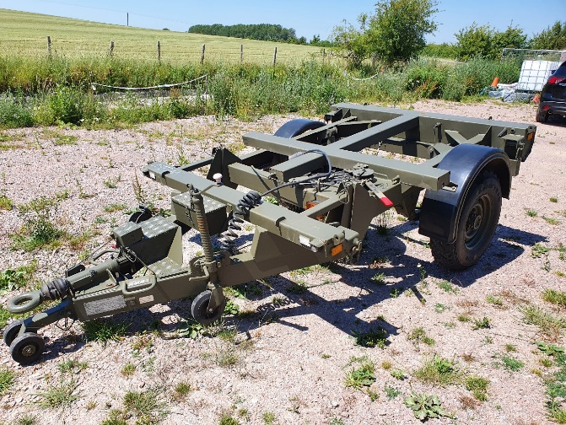

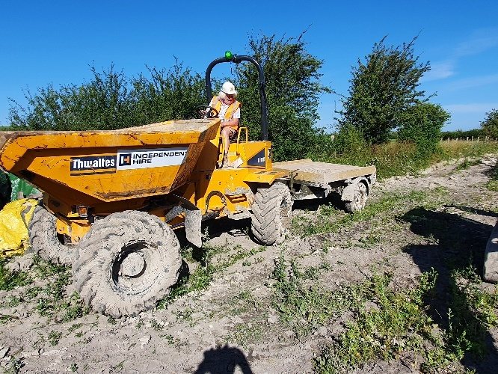
Modified trailer undergoing first trials in the mud.
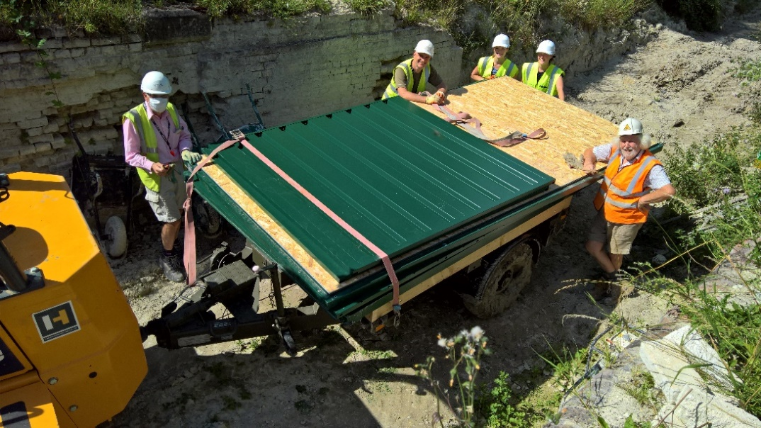
The first item to be moved was the new welfare hut, which was assembled on the second day.

The group standing close together are all from the same family!
After clearing a stack of old reclaimed bricks and pumping water out, it was found that machines could run along the bed back to the area known as Whitehouses. This was important for us because we needed to be able travel back on the section that has been finished to complete the brick work on the walls and manhole. This could not be achieved earlier in the year due to the bed being saturated from the heavy rain at the start of the year. The focus of transport was changed to getting the required materials to Whitehouses and start work on clearing the vegetation. Over several days concrete blocks and bricks were transported to both bridge 4 and Whitehouses work areas.
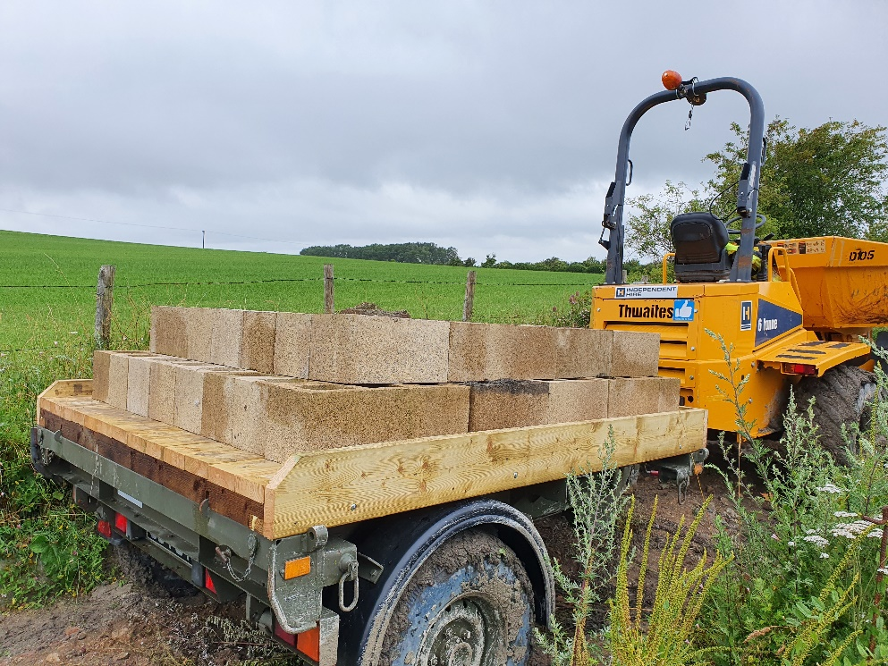
Here is the trailer with a 2/3 load of blocks. This being the maximum allowed without ratchet strap tie downs
After a consultation with our farmer next door the fence materials for the Whitehouse tip area were moved from where stored on his farm to our site, and work on the fencing has progressed through the work party. The fence will be finished next month to allow sheep netting to be added and handed over to the sheep!
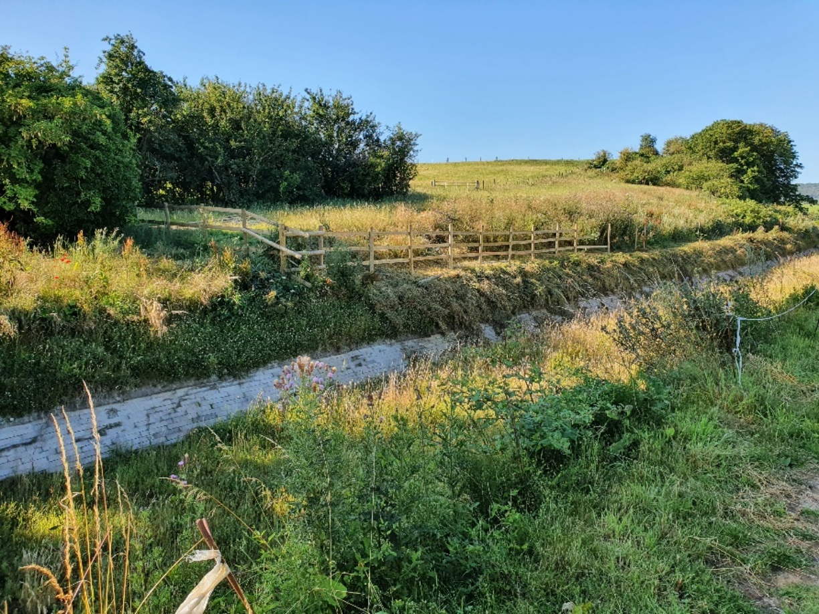
Here we can see the progress of the fencing. This area is larger than it looks here! This area was a steep slope before WAT rebuilt it with surplus spoil and topsoil.
To keep the work groups separated several tasks were performed simultaneously. We had one person building the hollow block wall at bridge 4, a Team on the fencing and others moving the materials.
Although the vegetation growth has been dramatic it did not affect the work tasks.
Safety improvements
During the work party some new issues became obvious to the volunteer teams. The first was the way we arrive in the car park. We do not have any facility for giving masks and other protective equipment to volunteers as they arrive because it is all stored in the hut at Bridge 4 (400m away!). There is also a lot of paperwork to sign and no convenient place to do that if the weather is bad. We are purchasing yet another, smaller, hut. This will be sited next to the car park in full view of the footpath to deter malicious folk. The hut can be used to store some of the equipment used in that area and which is currently “hidden” elsewhere on the site.
The new welfare hut at bridge 4 requires some internal fixtures and fittings to make it useable. Although we have water, kettles, and a generator etc. There are no work tops or storage facilities. A general request has been made amongst the Volunteer group for used kitchen units and work tops. If nothing results, we will purchase some basic kit (e.g. work tops) to make the hut more useable. We will also be able to store some of the critical safety equipment such as masks, safety glasses, the defibrillator and so on away from the dusty storage hut we already have.
The work site will also have updated Health and safety signage. This will be done in the next work party.
Trailer
We recognised significant risks when handling concrete blocks. Observations were made over a period and something needed to be done. Although we use a hydraulic grab to load blocks using an excavator, getting them off the dumper (both wheeled and tracked) was always a task that caused concerns. As soon as anyone climbs into a dumper to manhandle the blocks out, they are effectively working at an unsafe height and standing in or on an unstable pile of blocks. It has not been possible to get the blocks out with a hydraulic grab because the blocks move about in transit and the grab cannot grab them. This is especially the case with wheeled dumpers due to the shape of the bucket floor. After some discussion with the team it was decided to purchase a suitable trailer to be towed by a dumper and convert it to our needs. Of course, when you start looking at the load a trailer would need to carry to make each transport trip economical, it rules out most road going trailers straight away. Luckily, our Military services regularly cast redundant or time expired equipment and one of those was thought to be suitable. It also has Land rover wheels and tyres to allow easy maintenance. A one-day rapid modification team was assembled, and the trailer converted to a flat bed.
Further work will be needed to allow ratchet straps and boards to be used with 3 or 4 high block stacks

CDM Progress
This document records the issuing of an F10 form to the H and S Executive by CRT. This tells the Health and Safety Executive what we are doing, who is doing it and how long it will take.
We have also been issued with a new CRT form CDM 3.2 which reappoints WAT as Principle Contractors for another year. We now also have a Principal Designer from CRT allocated to us.
General
We have had a good response for volunteer numbers, and they were particularly good at following the C19 avoidance rules.
Next work party.
The August work party has been extended for an extra week. The extra week may be a “reduced work force event” to allow block and brick work at Whitehouse to continue with “distanced” teams.

Tony Bardwell
Please note my new email address:
tony.bardwell@wendoverarmtrust.co.uk
Operations Director

