THE WENDOVER ARM TRUST
WORKING PARTY NEWS
ISSUE 126 April 2018

March and April Working Parties

Weather did not permit any progress on lining work other than a short length of canal bed. To have attempted any more work would have been counter-productive.

Instead the working parties concentrated on clearing the vegetation on the banks between Bridge 4 and the cart track. “Old Man’s Beard” had taken over a great deal of it and is notoriously difficult to remove.

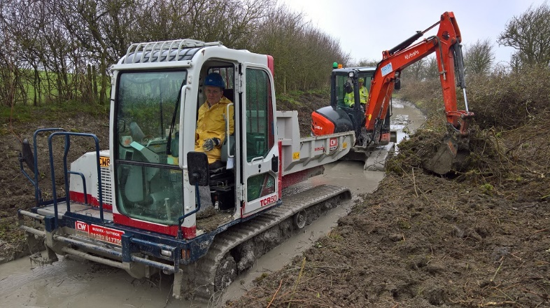
Stephen Bonser
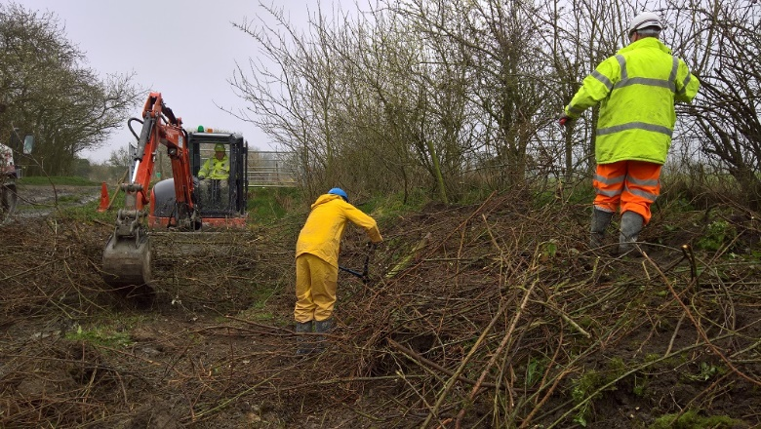
Stephen Bonser
THESE PICTURES ILLUSTRATE HOW THE BANKS LOOK AFTER CLEARANCE OF THE GROWTH SHOWN BELOW AND ALSO THE DEEP MUD IN THE BED OF THE CANAL

At the April working party the Portaloo was taken from Whitehouses, where it is kept, to Little Tring for one of the routine services.

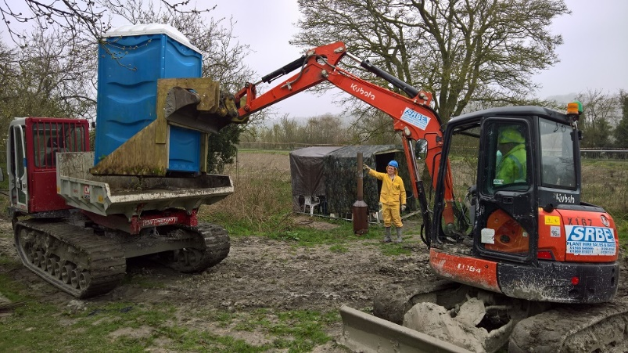
Stephen Bonser
THIS IS HOW THE PORTALOO GETS TRANSPORTED FOR ROUTINE SERVICING

May and June Working Parties

Hopefully bank and bed lining will start again and progress made but there is a great deal of work to do clearing up the ravages of the bad weather before productive work can re-commence.

Whitehouses

Although the design for the false weir in front of the wharf wall was completed in November last year we still await the contract price from CRT. It is essential that this work is completed this year in order to avoid holding up the Trust’s lining work.

Tidy Friday

John Reynolds and his team continue with their good work of vegetation control. See schedule on page 3 for dates. In April new saplings supplied by David Page were planted.

This is valuable work and I am sure John would like to hear from anyone able to spare a Friday once a month.

6-monthly physical and financial progress report

Firstly I must apologise for a ‘typo’ in my October report. An eagle eyed reader of this newsletter with time on his hands spotted that certain figures did not add up correctly although the totals were correct. I have a computer program that produces all the financial figures including totals but not in the form I use in the newsletter. Therefore I have to manually enter them into the newsletter and I am afraid I got one entry wrong.

Resulting from the suspension of the Heritage Lottery bid I have reviewed my estimates but it is difficult to put figures on the lining stages yet to be completed so I have left them as they are pending clarification of future restoration work. I have reviewed the cost for Stages 3, 4 and 10 in the light of current costs and progress and on the basis that most of the work will be executed by the Trust’s volunteers and also reviewed overhead costs.

Stage 3 is the first stage to exceed the estimate of £175,000/stage made over 10 years ago. There are 3 major factors leading to what I estimate will be a cost of £225,00 for this stage:

The route of the 18” pipeline in front of the Herts County Council tip ran under a very high offside bank that had to be removed to allow pipe capping and then reinstated and consolidated, a heavy plant hire cost.

Dreadful weather conditions this winter; not only does hired plant stand idle while pumping takes place but volunteers work more slowly in deep mud and water rather than a dry site. For one work party an attempt to delay the delivery of hired plant from Friday to Monday failed because the hire firm could not deliver on the Monday.

The extra plant hire cost arising from the closure of Morgans and the above reasons. Stage 2 plant hire costs were £98,000 compared with £85,000 for Stage 1 (the Stage 1 figure has been extrapolated from an actual £78,200 as Stage 1 was about 30 metres shorter than the others). The plant hire costs for Stage 3 are already £112,249 and the stage is only about 80% complete.

Stage 4 is fairly straightforward with part of the capping and the mooring wall already completed but, allowing for weather and higher plant hire costs, I am increasing the estimate to £200,000 although part of this stage may eventually be done under contract.

Stage 10, Whitehouses, awaits an estimate from CRT for their contract work that includes the short length of pipe capping. The Trust will line the rest of the bed and the towpath bank. The Trust has so far spent £17,552 on this stage and CRT have said that they are going to complete the heritage work. Until we get a firm figure from CRT I am adding £50,000 to this stage.

The full report is on page 3.

General Notes

We operate as a self-supervising group under CRT and all volunteers receive and sign for the Trust’s
Restoration Handbook that includes full Health and Safety requirements for the restoration works.

The handbook is the property of the Trust; if you leave the working parties for any reason, please return your Handbook to either Ray Orth or myself.

Hard hats for use at all times and high visibility jackets to be worn on sites with mobile plant in use are kept in the store at Tringford and must be drawn/returned there.

One first aid kit is kept in the store and one in the Nissan Cabstar and each qualified first-aider will have their own kit with him/her when on site.

Also available in the store at Tringford are ear defenders and goggles that must be worn when using strimmers, angle grinders, concrete breakers and the
like. CRT will supply hard hats, gloves and footwear with reinforced toecaps on request.

We normally work from 9am to 5pm (or dark if earlier!). There are breaks for morning tea/coffee, packed lunch and afternoon tea/coffee. We take our own food and drink.

WENDOVER ARM CANAL RESTORATION PHASE II

PROGRESS REPORT AS AT 12th APRIL 2018

CANAL LINING
Item | Stage 1 | Stage 2 | Stage 3 | Stage 4 | Stage 5 | Stage 6 | Stage 7 | Total
Total length | 321m | 350m | 350m | 350m | 350m | 337m | -
Complete to date:
Bulk Excavation | 321m | 350m | 340m |  |  |  | ---------
Capping to pipe | 321m | 350m | 340m | 126m |  |  | ---------
Tipping to offside bank | 321m | 350m | 310m |  |  |  | ---------
Tipping to towpath bank | 321m | 350m | 294m
Profiling offside bank | 321m | 350m | 269m |  |  |  | ---------
Profiling towpath bank | 321m | 350m | 285m |  |  |  | ---------
Lining towpath bank | 321m | 350m | 262m |  |  |  | ---------
Lining offside bank | 321m | 350m | 262m |  |  |  | ---------
Level and line bed | 321m | 350m | 230m |  |  |  | ---------
Planting banks | 60m | -------- | -------- |  |  |  | ---------
Mooring wall length | 50m | 50m | -------- | 50m | --------- | -------- | 237m
Excavation | 50m | 50m | -------- | 50m | -------- | -------- | 10m
Blinding | 50m | 50m | -------- | 50m | -------- | --------
Wall base | 50m | 50m | -------- | 50m | -------- | --------
Wall upright | 50m | 50m | -------- | 50m | -------- | --------
Backfill | 50m | 50m | -------- | 50m | -------- | --------
Estimated Cost | £128,272 | £154,579 | £225,000 | £200,000 | £166,250 | £98,725 | £53,725 | £1,026,551
Cost to date/final | £128,272 | £154,579 | £180,018 | £32,462 | £2,815 | £304 | £633 | £499,083

FOOTBRIDGES & VARIOUS OTHER WORKS
Item | Stage 8 | Stage 9 | Stage 10 | Stage 11 | Stage 12 | Stage 13 | Stage 14 | Total
 | Bridge 4 | Bridge 4A | Whitehouses | Cart track  Narrows | Removal  of bunds | Winding  Hole nose | Nuttalls  Bund
Footbridge | 100% | 100% | ---------------- | ----------- | ---------- | ----------- | ----------
Excavation | 100% | 100% | ---------------- |  | ---------- |  | ----------
Blinding | 100% | 100% | ---------------- |  | ---------- |  | ----------
Wall base | 100% | 100% | ---------------- |  | ---------- |  | ----------
Wall upright | 100% | 100% | ---------------- |  | ---------- |  | ----------
Backfill | 100% | 100% | ---------------- |  | ---------- |  | ----------
Heritage work | --------- | --------- | 100% | ----------- | ---------- | ----------- | ----------
Other work | --------- | --------- | 100% | ----------- |  | ----------- | 100%
CRT contract | --------- | --------- |  | --------- | --------- | --------- | ---------
Estimated cost | £20,122 | £20,031 | £67,552 | £20,000 | £20,000 | £10,000 | 3,501 | £161,206
Cost to date/final | £20,122 | £20,031 | £17,552 |  |  |  | 3,501 | £61,206

SUMMARY INCLUDING OVERHEAD COSTS AND PHASE I
 | Lining | F/bridges  & other  works | Clear bed,  & Temp’y  Works | Environ’t  Reports | Materials  In stock | Admin | Tools &  Equip’t | Vehicle | Unallocated  contingency | TTOTAL
Estimated cost | £1,026,551 | £161,206 | £22,000 | £3,245 | £0 | £43,000 | £12,000 | £25,000 | £40,000 | £1,333,002
Cost to date/final | £499,083 | £61,206 | £21,417 | £3,245 | £3,792 | £36,477 | £10,649 | £21,060 | £0.00 | £656,929
Final cost of Phase I completed in 2004 and opened to navigation in 2005 |  |  |  |  |  |  |  |  |  | £400,349
Total spend on restoration by Wendover Arm Trust to date |  |  |  |  |  |  |  |  |  | 1,057,278
A red figure indicates a final cost/physical progress. A green figure indicates a revised budget figure, either to match a finished cost or to give a re-appraisal in the light of experience to date.

WORKING PARTIES

So you can plan your diary ahead, the following are the dates of future working parties. The work to be done is very much subject to the weather especially during the winter months.

DATE | WORKING AT | WORK TO BE DONE
2018
Friday 4th May to  Thursday 10th May | Stage 3 | Stage 3 profiling and lining.
Friday 11th May | Meet at Little Tring | ‘Tidy Friday’ vegetation control working party
Friday 1st June to  Thursday 7th June | Stage 3 | Stage 3 profiling and lining.
Friday 8th June | Meet at Little Tring | ‘Tidy Friday’ vegetation control working party
Friday 6th July to  Thursday 12th July | Stage 4 to Bridge 4 | Stage 3 profiling and lining.
Friday 3rd August to  Thursday 9th August | Stage 4 to Bridge 4 | Stage 3 profiling and lining.
Friday 31st August to  Thursday 6th September | Stage 4 to Bridge 4 | Stage 3 profiling and lining.
Friday 5th October to  Thursday 11th October | Stage 4 to Bridge 4 | Stage 4 profiling and lining subject to CRT work at Whitehouses being completed.
Friday 2nd November to  Thursday 8th November | Stage 4 to Bridge 4 | Stage 4 profiling and lining subject to CRT work at Whitehouses being completed.
Friday 30th November to  Thursday 6th December | Stage 4 to Bridge 4 | Stage 4 profiling and lining subject to CRT work at Whitehouses being completed.

Roger Leishman, Restoration Director.
7 Hall Park, Berkhamsted, Herts HP4 2NU.
Tel: 01442 874536,
e-mail rwleishman@gmail.com

