THE WENDOVER ARM TRUST
WORKING PARTY NEWS
ISSUE 123 October 2017

September and October Working Parties

Bank and bed lining proceeded during these working parties and the 350 metres of Stage 3 is now fully lined for 221 metres and both banks completed for 246 metres.
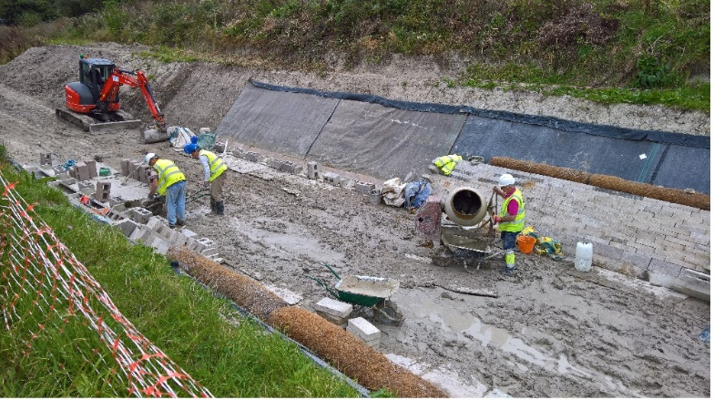
Stephen Bonsor
RELINING WORK IN PROGRESS
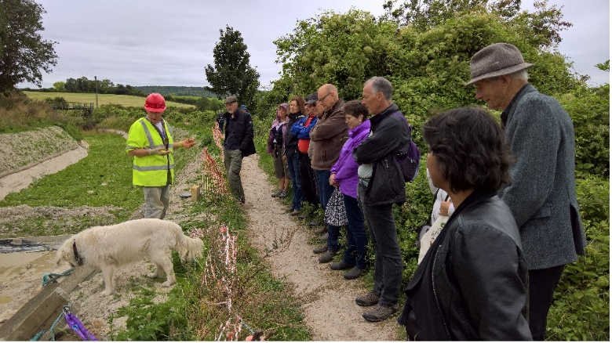
Stephen Bonsor
RAY ORTH EXPLAINING THE WORKS TO VISITORS AT THE SEPTEMBER OPEN DAY

At present rate of progress lining work will approach Whitehouses in about six or seven months, entirely dependent on weather conditions during the forthcoming winter.

Whitehouses

The latest news on the design and progress of the pseudo weir and wing walls to the wharf wall at Whitehouses is that the design has just been received by WAT and is at present being costed by CRT. No firm date for this work has been agreed although a date of April/May next year has been suggested but attempts are being made to bring this forward to avoid clashing with WAT’s work that should have reached Whitehouses about that time.

Tidy Friday

John Reynolds and his team continue with their good work of vegetation control. See schedule on page 3 for dates. We are most grateful to Tring Lions for helping to fund the purchase of a new brush cutter for this group.
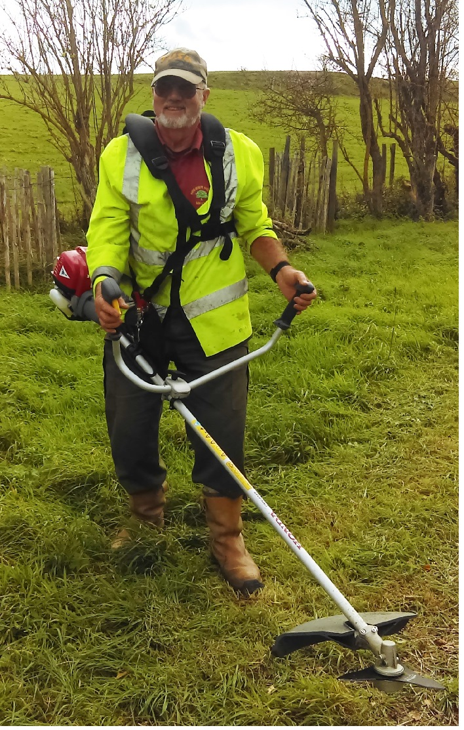
Chris Sargeant
JOHN REYNOLDS WITH THE NEW BRUSH CUTTER

6-Monthly Physical and Financial progress report

This seems to come round again very quickly and is on page 4.

Working Party News Distribution

As many of you may already know, John Reynolds is moving from Tring to Bedfordshire although we hope that he will be able to continue with the Tidy Friday working parties.

John has, however, asked to be relieved of the working party news distribution and Clive Johnson has agreed to take over the job.

Many thanks to John for his distribution work and a grateful thank you to Clive for taking it over.

General notes
We operate as a self-supervising group under CRT and all volunteers receive and sign for the Trust’s Restoration Handbook that includes full Health and Safety requirements for the restoration works.

The handbook is the property of the Trust; if you leave the working parties for any reason, please return your Handbook to either Ray Orth or myself.

Hard hats for use at all times and high visibility jackets to be worn on sites with mobile plant in use are kept in the store at Tringford and must be drawn/returned there.

One first aid kit is kept in the store and one in the Nissan Cabstar and each qualified first-aider will have their own kit with him/her when on site.

Also available in the store at Tringford are ear defenders and goggles that must be worn when using strimmers, angle grinders, concrete breakers and the like. CRT will supply hard hats, gloves and footwear with reinforced toecaps on request.

We normally work from 9am to 5pm (or dark if earlier!). There are breaks for morning tea/coffee, packed lunch and afternoon tea/coffee. We take our own food and drink.

WORKING PARTIES

So you can plan your diary ahead, the following are the dates of future working parties. The work to be done is very much subject to the weather especially during the winter months.

DATE | WORKING AT | WORK TO BE DONE
2017
Friday 3rd November to  Thursday 9th November | Stage 3 | Stage 3 profiling and lining.
Friday 10th November | Meet at Little Tring | ‘Tidy Friday’ vegetation control working party
Friday 1st December to  Thursday 7th December | Stage 3 | Stage 3 profiling and lining.
Friday 8th December | Meet at Little Tring | ‘Tidy Friday’ vegetation control working party
2018 | Meet at Little Tring
Friday 5th January to  Thursday 11th January | Stage 3 | Stage 3 profiling and lining.
Friday 12th January | Meet at Little Tring | ‘Tidy Friday’ vegetation control working party
Friday 2nd February to  Thursday 8th February | Stage 3 | Stage 3 profiling and lining.
Friday 9th February | Meet at Little Tring | ‘Tidy Friday’ vegetation control working party
Friday 2nd March to  Thursday 8th March | Stage 3 | Stage 3 profiling and lining.
Friday 9th March | Meet at Little Tring | ‘Tidy Friday’ vegetation control working party
Friday 6th April to  Thursday 12th April | Stage 3 | Stage 3 profiling and lining.
Friday 13th April | Meet at Little Tring | ‘Tidy Friday’ vegetation control working party
Friday 4th May to  Thursday 10th May | Stage 3 | Stage 3 profiling and lining.
Friday 11th May | Meet at Little Tring | ‘Tidy Friday’ vegetation control working party
Friday 1st June to  Thursday 7th June | Stage 3 | Stage 3 profiling and lining.
Friday 8th June | Meet at Little Tring | ‘Tidy Friday’ vegetation control working party
Friday 6th July to  Thursday 12th July | Stage 4 to Bridge 4 | Stage 4 profiling and lining.
Friday 3rd August to  Thursday 9th August | Stage 4 to Bridge 4 | Stage 4 profiling and lining.
Friday 31st August to  Thursday 6th September | Stage 4 to Bridge 4 | Stage 4 profiling and lining.
Friday 5th October to  Thursday 11th October | Stage 4 to Bridge 4 | Stage 4 profiling and lining.
Friday 2nd November to  Thursday 8th November | Stage 4 to Bridge 4 | Stage 4 profiling and lining.
Friday 30th November to  Thursday 6th Decenber | Stage 4 to Bridge 4 | Stage 4 profiling and lining.

Roger Leishman, Restoration Director.
7 Hall Park, Berkhamsted, Herts HP4 2NU.
Tel: 01442 874536,
e-mail rwleishman@gmail.com

WENDOVER ARM CANAL RESTORATION PHASE II

PROGRESS REPORT AS AT 12th OCTOBER 2017

CANAL LINING
Item | Stage 1 | Stage 2 | Stage 3 | Stage 4 | Stage 5 | Stage 6 | Stage 7 | Total
Total length | 321m | 350m | 350m | 350m | 350m | 337m | -
Complete to date:
Bulk Excavation | 321m | 350m | 340m |  |  |  | ---------
Capping to pipe | 321m | 350m | 340m | 126m |  |  | ---------
Tipping to offside bank | 321m | 350m | 290m |  |  |  | ---------
Tipping to towpath bank | 321m | 350m | 290m
Profiling offside bank | 321m | 350m | 265m |  |  |  | ---------
Profiling towpath bank | 321m | 350m | 265m |  |  |  | ---------
Lining towpath bank | 321m | 350m | 246m |  |  |  | ---------
Lining offside bank | 321m | 350m | 246m |  |  |  | ---------
Level and line bed | 321m | 350m | 221m |  |  |  | ---------
Planting banks | 60m | -------- | -------- |  |  |  | ---------
Mooring wall length | 50m | 50m | -------- | 50m | --------- | -------- | 237m
Excavation | 50m | 50m | -------- | 50m | -------- | -------- | 10m
Blinding | 50m | 50m | -------- | 50m | -------- | --------
Wall base | 50m | 50m | -------- | 50m | -------- | --------
Wall upright | 50m | 50m | -------- | 50m | -------- | --------
Backfill | 50m | 50m | -------- | 50m | -------- | --------
Estimated Cost | £128,272 | £154,579 | £175,000 | £175,000 | £166,250 | £98,725 | £53,725 | £951,551
Cost to date/final | £128,272 | £154,579 | £154,579 | £32,462 | £1,042 | £304 | £633 | £481,126

FOOTBRIDGES & VARIOUS OTHER WORKS
Item | Stage 8 | Stage 9 | Stage 10 | Stage 11 | Stage 12 | Stage 13 | Stage 14 | Total
 | Bridge 4 | Bridge 4A | Whitehouses | Cart track  Narrows | Removal  of bunds | Winding  Hole nose | Nuttalls  Bund
Footbridge | 100% | 100% | ---------------- | ----------- | ---------- | ----------- | ----------
Excavation | 100% | 100% | ---------------- |  | ---------- |  | ----------
Blinding | 100% | 100% | ---------------- |  | ---------- |  | ----------
Wall base | 100% | 100% | ---------------- |  | ---------- |  | ----------
Wall upright | 100% | 100% | ---------------- |  | ---------- |  | ----------
Backfill | 100% | 100% | ---------------- |  | ---------- |  | ----------
Heritage work | --------- | --------- | 90% | ----------- | ---------- | ----------- | ----------
Other work | --------- | --------- | 100% | ----------- |  | ----------- | 100%
Estimated cost | £20,122 | £20,031 | £20,000 | £20,000 | £20,000 | £10,000 | 3,501 | £113,654
Cost to date/final | £20,122 | £20,031 | £17,552 |  |  |  | 3,501 | £61,206

SUMMARY INCLUDING OVERHEAD COSTS AND PHASE I
 | Lining | F/bridges  & other  works | Clear bed,  & Temp’y  Works | Environ’t  Reports | Materials  In stock | Admin | Tools &  Equip’t | Vehicle | Unallocated  contingency | TTOTAL
Estimated cost | £951,551 | £113,654 | £22,000 | £3,245 | £0 | £37,000 | £11,000 | £22,000 | £40,000 | £1,200,450
Cost to date/final | £481,126 | £61,206 | £21,284 | £3,245 | £3,792 | £34,579 | £10,797 | £21,006 |  | £613,650
Final cost of Phase I completed in 2004 and opened to navigation in 2005 |  |  |  |  |  |  |  |  |  | £400,349
Total spend on restoration by Wendover Arm Trust to date |  |  |  |  |  |  |  |  |  | £1,037,384

A red figure indicates a final cost/physical progress. A green figure indicates a revised budget figure, either to match a finished cost or to give a re-appraisal in the light of experience to date.

