Wendover Arm Trust V1 23 Feb 2020
Operations Report February 2020

Volunteer safety
No incidents or injuries or near misses were reported. We now have a good safety record: - we need to keep thinking about what we do and how we can make it easier and safer for our precious work force. Ideas and suggestions are always welcomed.
Several of our regular volunteers have attended formal training courses in their own time and we should be thankful to them for their input into our safety systems.
Work Party progress
Overview.
Throughout the work party the working area was pumped out regularly before work could start. We had a visit from storm Ciara and had to stop work for one day before we pumped out and got going again. Challenging conditions to say the least!
Day by Day, blow by blow
Thursday
The work party started on Thursday this month. We asked for, and got, enough volunteers to hand mix concrete and lay the remaining length of hollow blocks through the bridge. This activity was done without any plant/machinery because we planned for it last month and made sure the materials and equipment were in the right place.
The Thursday work allowed the ready mixed reinforced concrete bed to be laid through the remainder of the bridge on Friday. The concrete was carried from lorry to site by 6 tonne wheeled dumpers. A vibrating poker was used to de-aerate the concrete over the reinforcement mesh.
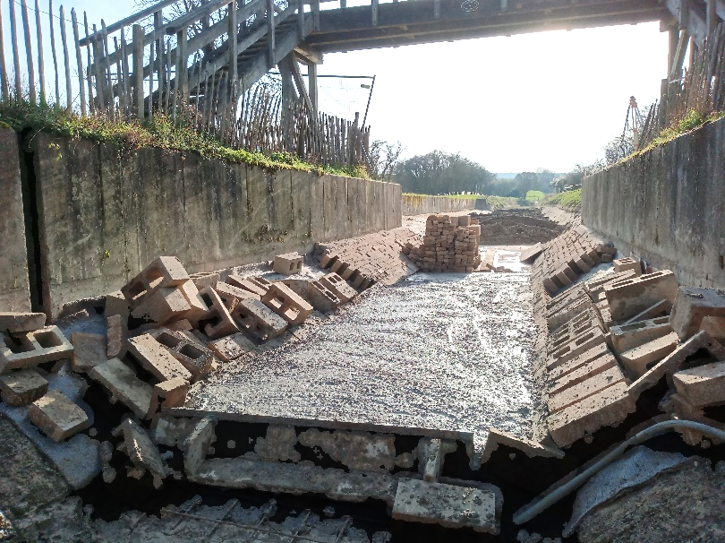
Bridge 4. Picture taken just after the concrete was de-aerated
Saturday
Seven volunteers, arrived on what turned out be a very nice day, the “calm before the storm”. 144 solid concrete blocks were taken to the work site, most of these were laid onto the concreted hollow blocks except for the top row which was temporarily left off to allow Bentonite paste to be mixed and put in place behind the Bentomat at the top edge. The volunteer person who applied the paste also applied a lot of weather proofing to her jacket (maybe in preparation for storm Ciara?).
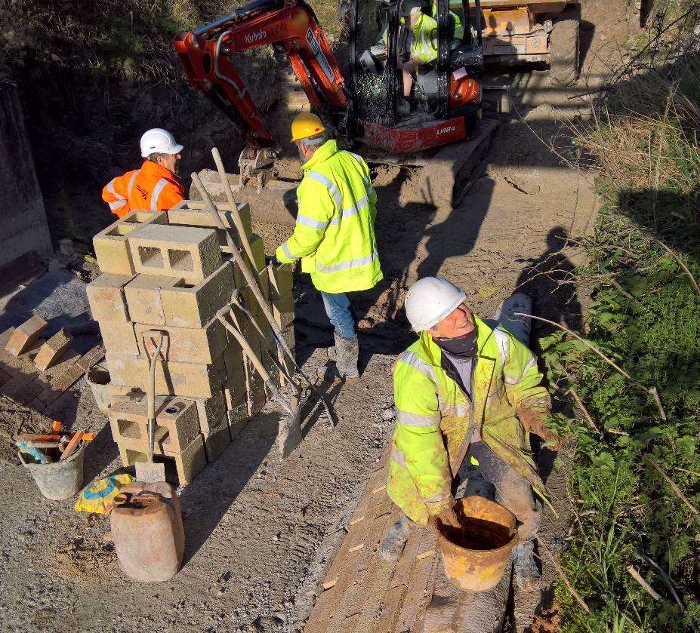
Unconventional jacket waterproofing?
Concurrently, the sloping parts of the old Swing Bridge wing walls were demolished (in accordance with the CRT approved drawings).
We also excavated down to the required bed depth in the local area. The excavation allowed us to discover some brickwork going across the canal which included a large stone like the one set into the top of the swing bridge wall on the tow path side - it had the same vertical lines on one face. We wondered if they were the supports for the bridge side beams when it was across the canal. We also recovered some more bricks from this area, although they appear to have been installed with concrete mortar, there was no break in the brick line so it was built after the pipeline was installed. This may have been part of a walkway taking the footpath across the canal bed before the current bridge 4 was built.
Sunday, Ciara strikes!
The 6 volunteers found a very windy morning, the car park being very exposed, and the wind was stronger here than anywhere else.
When loading a dumper with ballast (next to the car park) we had to make sure that no people (or cars!) were downwind - there was a very real risk of the wind picking up ballast whilst we loaded. (probably not a predictable risk?)
When approaching the work site on a dumper, the wind was gusting enough to take sand from the ballast and throw it in the driver’s face with some force - fortunately he was wearing safety glasses, so no harm was done to him. Full marks to him for wearing the right equipment!
The wind seemed to be aligned with the canal line and it was relentless. It was a bit of a scene of devastation when we got to site - in the canal itself things weren't too bad, but our simple shelter looked to have been inverted and completely flattened. The adjacent Heras type fence was also down. Whilst two members of the team carried on doing the hand finishing of the excavations the rest of us made safe the area where our shelter used to be - there was a risk that things could be blown across the canal towpath endangering members of the public. The chairs and covering were put into the Green hut and heavy weights used to hold plywood sheets down. All the damaged fencing was unbolted and laid flat. Quite a few of the fence panels were damaged. we'd lost our shelter, With the weather predicted to get worse (the rain was getting heavier) and having no shelter we abandoned work and left site in the howling wind and rain at 11:30.
Monday picking up the pieces.
There were only four of us on Monday because of the fallen trees and flooding causing travel problems.
The concrete mixer had survived and was used to make a “blinding layer” of concrete in the area that will be have reinforced concrete added later. This gave us much better working conditions.
The Heras fence adjacent to bridge 4 was rebuilt making our worksite secure. Our shelter components were damaged beyond use so the Green hut was used as a shelter instead.
Tuesday Wet but not raining all the time
The remaining part of the bridge banks were solid blocked and concreted including the old stop plank channels which will be replaced by the new ones in the new blockwork on the Tring end of the bridge.
Wednesday
Due to the concrete blinding needing more time to cure we worked on our latest memorial bench concrete slab. This was set up and cast in place. This involved taking the materials and equipment to the towpath site and doing most of the work by hand. This will be ready for the bench to be bolted in place in March.
Thursday, Double trouble
After a quick pump out and clear up, we set about assembling the required double layer concrete reinforcement mesh. The double mesh is required because the concrete slab will be 300mm thick. (The slab will form the foundations for the block and brick work walls and stop plank channels). Faced with several bags of odd shaped pieces of reinforcement, a pile of reinforcement sheets and a drawing, it was like solving a three-dimensional puzzle. After a false start, progress was made and around 80% of the reinforcement was put in place.
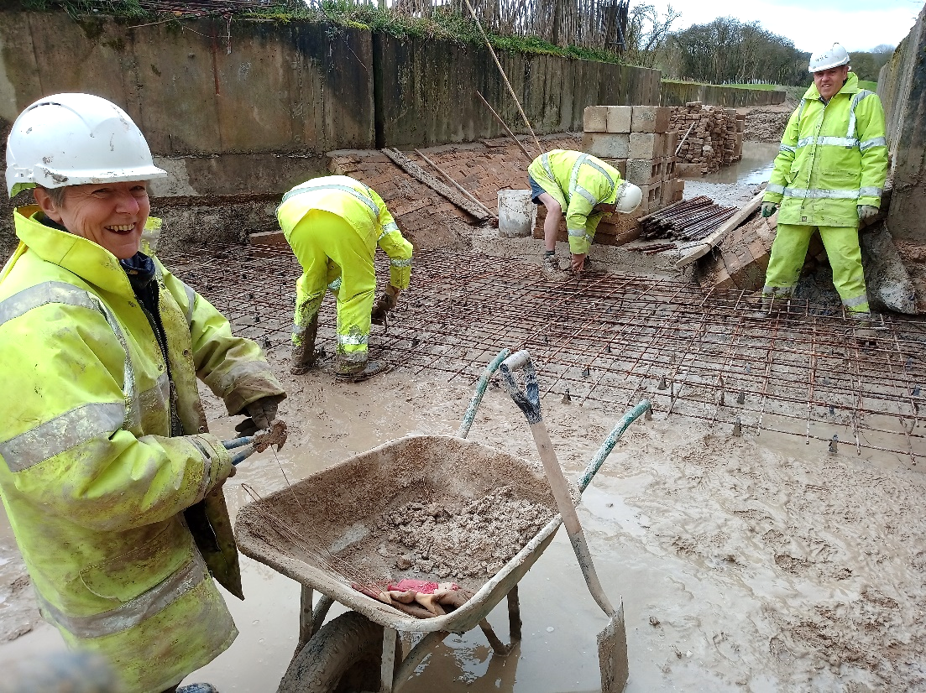
The
“Jolly Reinforcer’s” gang.
One of our adventurous volunteers managed to find a water feature (below) whose depth exceeded the height of her wellies. Wet socks and boots for the rest of the day. My warning was about half a second too late! (I didn’t laugh, really!)

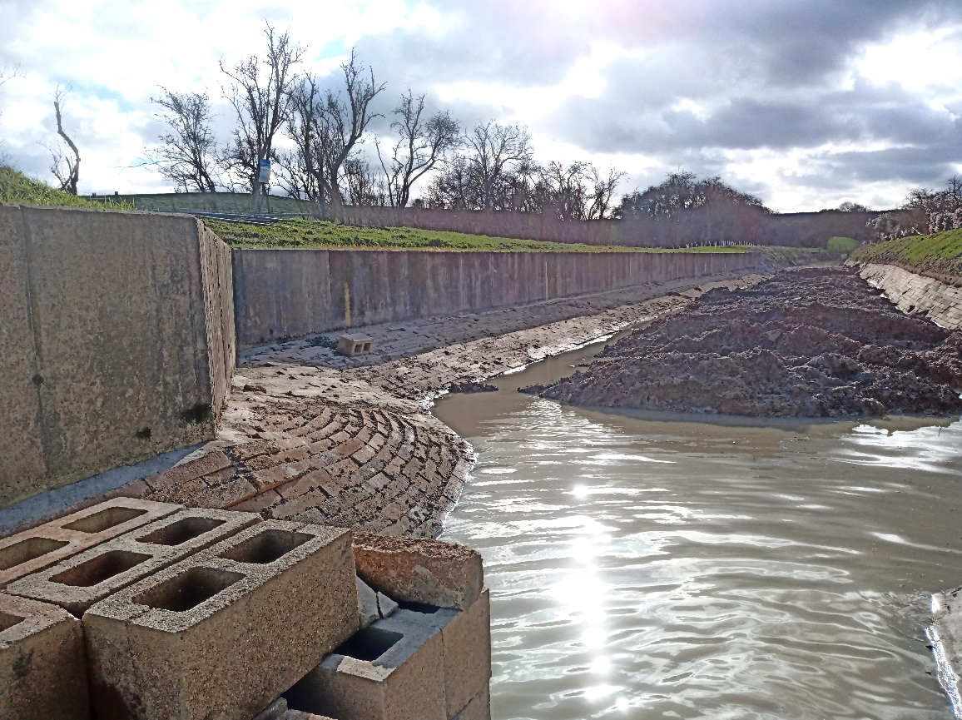
Beware the hidden depths!!

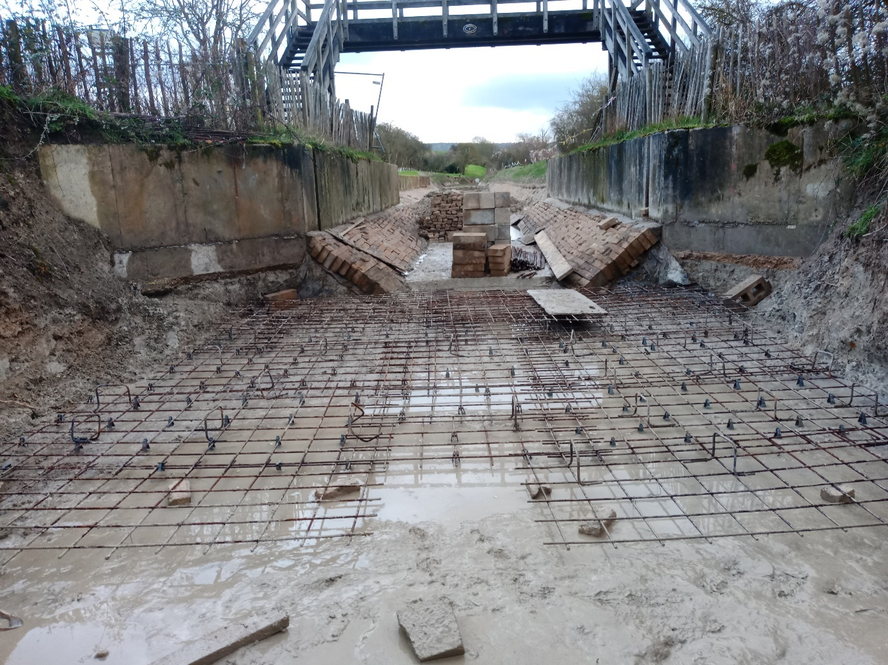
The final view before Storm Dennis arrived!

Tidy Friday
The tidy Friday team spent their time clearing up tree debris from the storm and had a warming bonfire: - there was a lot of wood around!

Tony

