Wendover Arm Trust V1 17/03/ 2020
Website: - http://wendoverarmtrust.co.uk/
Operations Report March 2020
Volunteer safety
Despite the wet and slippery conditions there were no reported injuries or incidents. We did have a few wet feet due to “water over the boot top” incidents which again highlighted the need for better shelter and drying facilities for the winter months.
Work Party progress
Overview.
The start of this working party was originally planned to get going on the Wednesday before the plant delivery day. Concrete was planned to be delivered and poured on Friday. Storm Jorge and the other wet days forced us to change our plans and abandon the Wednesday workday and move the concrete delivery and pouring until the following Monday. This gave us more time to pump all the water out and finish the reinforcing mesh for the concrete slab.
The main work planned for this month was to cast the main reinforced concrete slab that will eventually support the new stop plank channels and the rebuilt section of the Old Swing Bridge walls.
This work was done in several stages including casting the “upstand” where the stop planks will meet with the bed, and casting in an expansion joint with the existing concrete slab under bridge 4.
Thursday 5th
The plant machines arrived early, and this was a big bonus for us in terms of getting the water pumps in place to pump out the rainwater. The work area was pumped out quickly, so the opportunity was taken to pump out the large lake just before the work area and the semi-finished bed and concrete policemen on the other side of bridge 4……
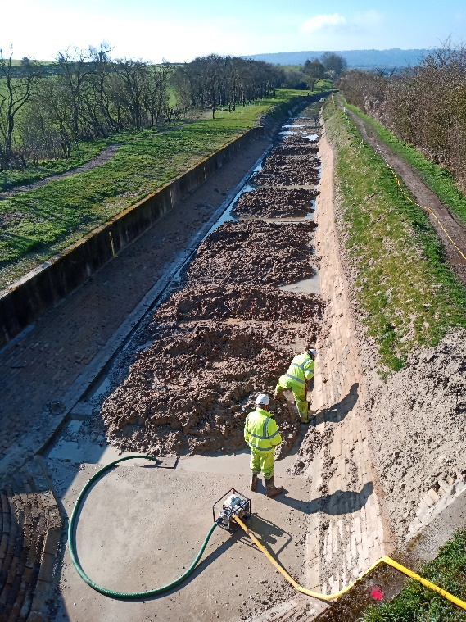
Pumping water from the Wendover side of Bridge 4
Friday 6th
Work commenced on sorting out the various pieces of the reinforcement puzzle including cutting the reinforcing sheet meshes and specially bent shapes to get the fit and height that was required.
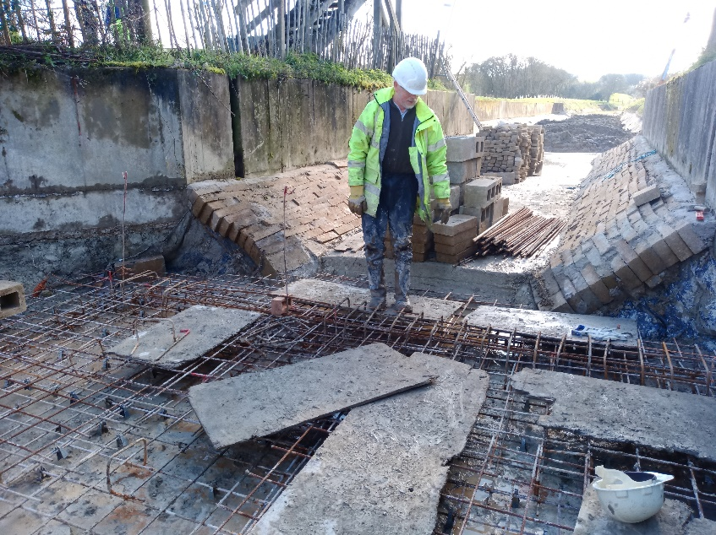
The reinforcement puzzle, about to be solved!
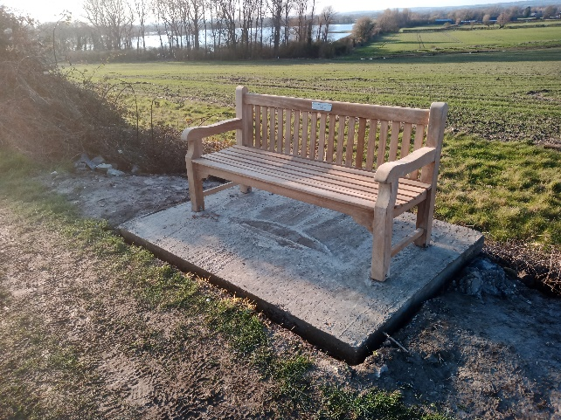
A Memorial bench, dedicated to “Mavis Hunt”, was installed and bolted down.

Saturday 7th
Whilst the on-site team carried on with the reinforcing, I went to look at a 2-tonne dumper that could be potentially donated to WAT and I decided straightaway that it would be a benefit to WAT for various duties.

We had 4 volunteers on this day and concentrated on getting the reinforcing etc. finished. We continued with attaching the 20mm dowels which will firmly locate the block walls whilst the central area of mesh was finished off. Meanwhile there was some more pumping out of the large “lake” nearest the worksite. After this we all moved on to installing wooden shuttering which took a while to get to the correct height and needed extra timber to fill gaps underneath. We had a visit at break time from our Chairman, Chris Sargeant, with cake! Very nice! (the cake!)

Sunday,8th
Dumper day.
Transport for the dumper was arranged over Saturday evening and Sunday morning and the Dumper arrived by trailer on site mid-afternoon. We will need to add a roll bar and seat belt (maybe add some paint) but the dumper should give us a safer way of transporting and offloading the many concrete blocks that we handle. Although the machine is smaller than the 6 tonne dumpers we normally use, the bucket is much lower to the ground.
Due to being lighter and smaller the “new” dumper may be able to travel back to Whitehouses along the bed where the larger machines would bog down due to the winter water in the bed spoil.
We are very grateful to the donors.

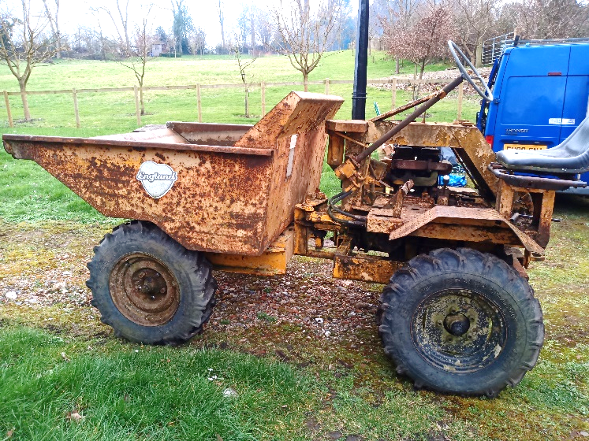
Our “new” dumper!
We ought to have a naming ceremony.?

Getting ready for the concrete

We had a new volunteer who was given the relevant H and S induction information and a hard hat.

We also tidied up the concrete pouring site and left it ready to go for Monday. We also removed enough spoil from the approach to the worksite to allow the dumpers access without spillage. The spoil was used to extend the filled area on the bank near to the new memorial bench. One of the volunteers had suggested that we construct a passing point to allow two dumpers to pass and ease the flow of dumpers when delivering the concrete. This was created as our last job before packing up for the day.

Monday 9th
Concreting day
We had rain overnight so there had to be yet another “pump out” before work could start.
The plan was that the ordered 12 cu m of concrete would be delivered by 3 ready mix lorries. Then, with each dumper loaded as high as we could, considering spillage due to the rough ground and slopes, there would be many shuttle trips.
We were all ready to go earlier than expected so arranged to bring the deliveries forward by half an hour. We should have organised a bigger time gap between the deliveries to compensate for the dumper transport distance from the Little Tring carpark to bridge 4!! Things soon developed into “a busy time”. The volunteer-suggested method of tipping the concrete into wheelbarrows directly from the dumper worked well provided we didn’t completely fill them. It is not easy to control concrete being tipped out of a dumper! To the team on top of the reinforcing, the flow of dumpers appeared to be relentless, and there was little time to recover between deliveries.
The whole of the concrete mas was de-aerated with a vibrating poker. This tended to allow the wooden from work to float up and some time was spent putting in more pins in strategic positions to show what the concrete level needed to be.
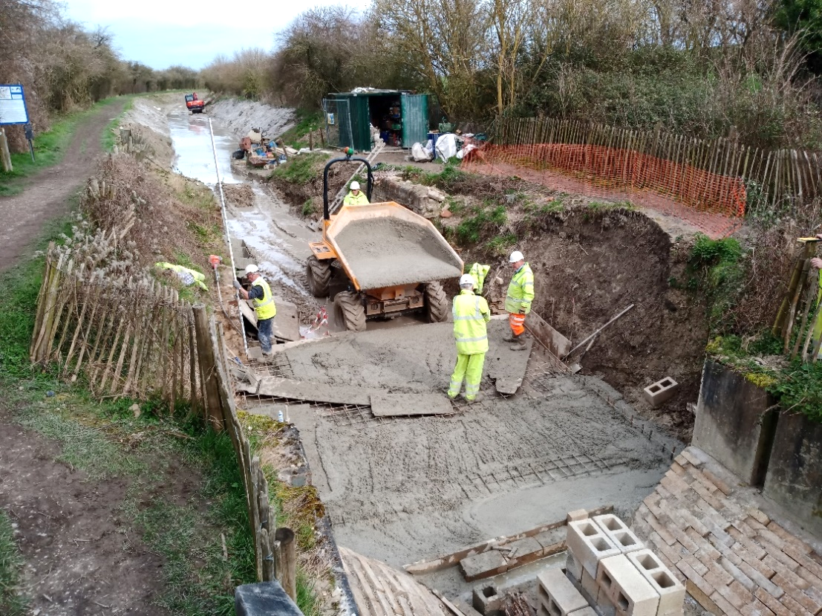
Final concrete delivery.
Note the large “lake” the dumpers had to travel through without spilling the load.
Fatigue amongst the volunteers was beginning to set in and more minor trips and incidents were seen to be happening. Adding more volunteers probably wouldn’t have helped much (due to getting in each other’s way), other than allowing more rotation of staff. We did rotate the dumper driving to give people a break.

Each dumper was pressure washed out. Everyone worked hard on what was a very busy, tiring day.

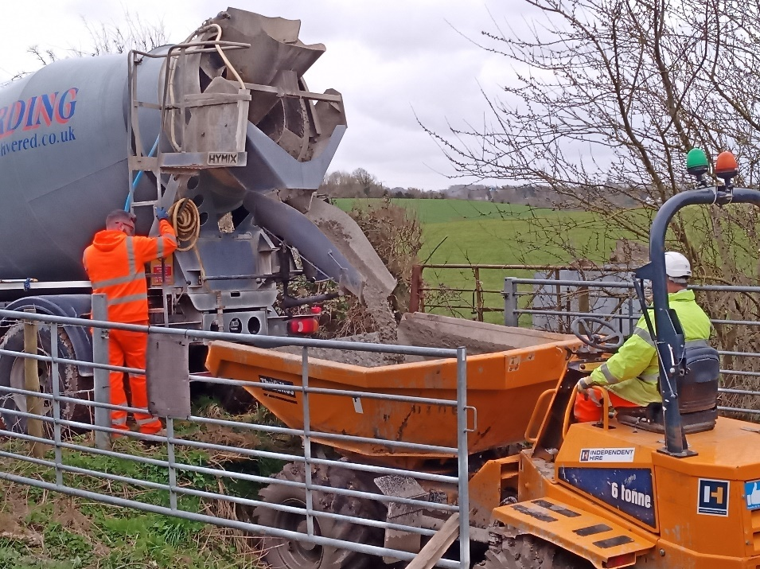
And this is how the concrete gets into the dumper truck

Tuesday 10th
Mind the Gap!
On Tuesday we witnessed the amazing ability for wet concrete to attract footprints.
But before all that, we had to strip out form work on the new concrete slab and pump out the area between the new slab and the existing slab under Bridge 4. As part of the preparations the “tail end” of the Bridge 4 slab reinforcement had to be uncovered and cleaned up.
A foam expansion strip was assembled to the face of the new slab to allow each slab to “move” or settle over time.
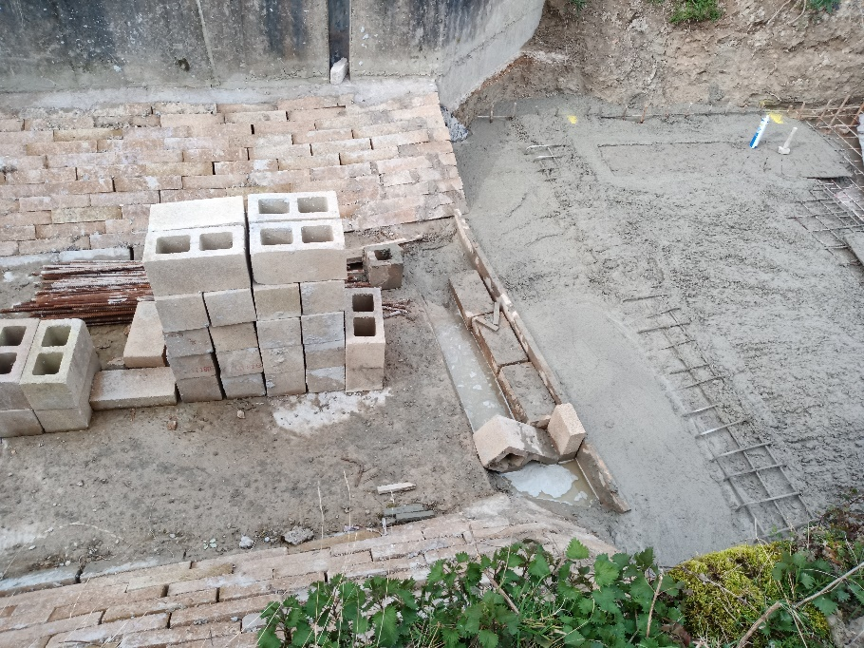
This is the where the connecting piece between the two slabs will be.
So, we “set to” on mixing concrete with our onsite mixer and filled the gap and de-aerated with a poker. This was followed by careful smoothing and lavish “finishing” by trowel.
All that smoothing was obviously vulnerable, so the area was covered with raised boards whilst we got on with the next bit. The boards soon got in the way so were removed and everyone was told to keep away. That lasted about ten minutes when I was the first to “make an impression”. Smoothing was difficult whilst laughing! Three more feet marks duly came and went. Then we had a volunteer who apparently wanted the shape of his face recorded for posterity He managing to stumble and almost perfect a “face plant”. No injuries, lessons learned and more laughter!
The task that was causing the footmarks next door was to fabricate and assemble the form work for the cill that will be the sealing face for the stop planks when they are assembled. The form work was again set up using the surveying level. Extra reinforcing was added and then the form work filled with hand mixed concrete.
Vibrating the concrete to de-aerate it cause yet more problems with the form work (we really should know by now?) and more time was spent correcting the movement and settling the concrete down again.
Wednesday 11th
First task was to “strike” and clear away the various form work and boards. Work started on the first course of hollow blocks which were placed over the dowels cast into the concrete bed.
Thursday, 12th
As a continuation of the expansion joint between the two concrete slabs, some more plastic foam was affixed to the bridge abutment wall. Work started in earnest on the hollow block work. Most of the block work on the offside was completed. Survey checks were done throughout the build.
The cill “upstand” was surveyed for flatness and height and was found to be satisfactory.
A bund was reinstated just beyond the old swing bridge walls to keep some of the water out.
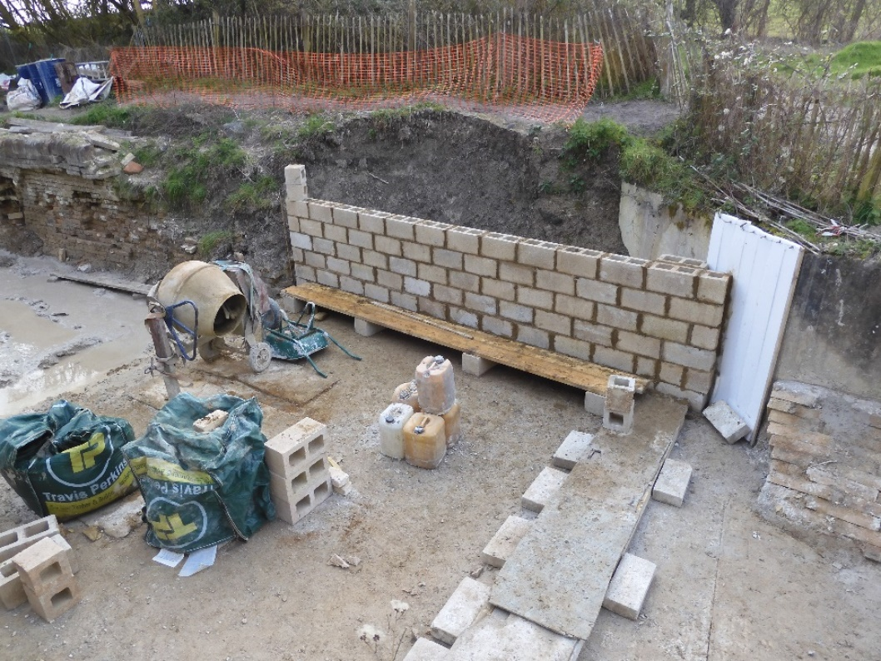
The main concrete slab, hollow block wall, plastic expansion joint and cill upstand (covered)

Here it is! The view from Bridge 4 at the end of the main work party
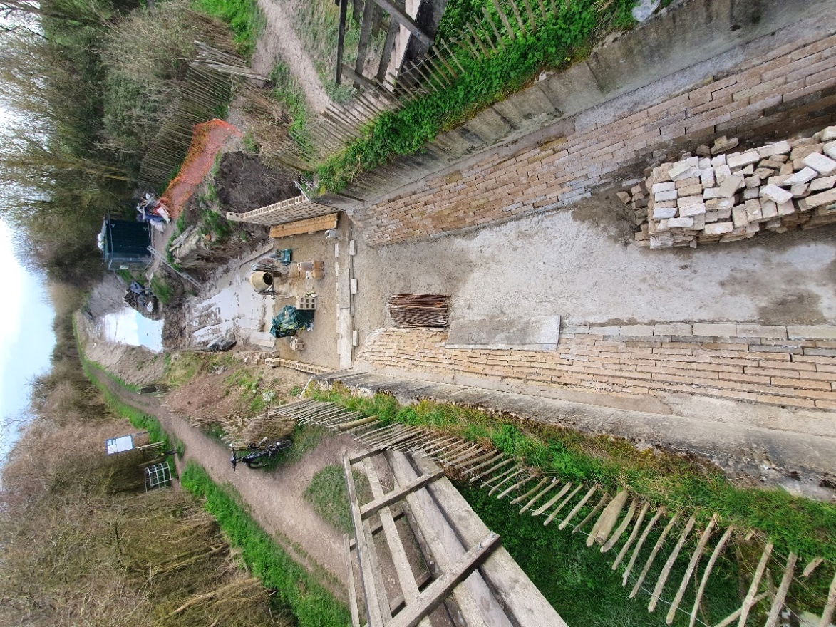

Friday 13th
Tidy Friday and plant return
The team had a new volunteer who came to us via a local university scheme. The day’s work included picking up the various branches and debris from the recent high winds, tending to the various trees and bulbs already planted.
We have been informed that there will be 450 more trees available to plant in the autumn!

Tony Bardwell

Operations

